**EXERCISE-1**

Creating and Managing tables

1. Create the DEPT table based on the DEPARTMENT following the table instance chart below. Confirm that the table is created.

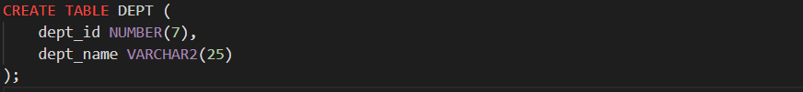

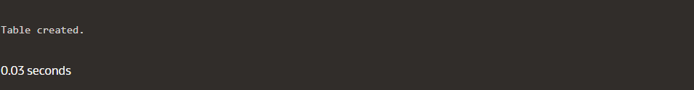

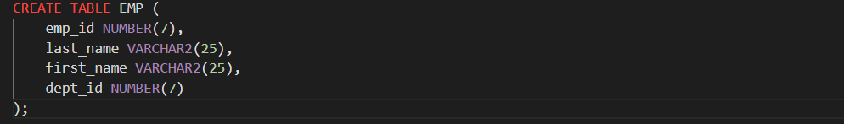2. Create the EMP table based on the following instance chart. Confirm that the table is created.

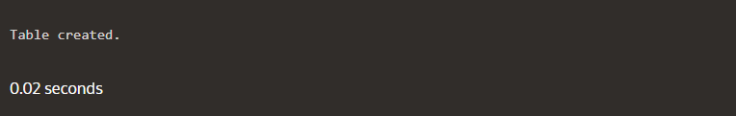

3. Modify the EMP table to allow for longer employee last names. Confirm the modification (Hint: Increase the size to 50)



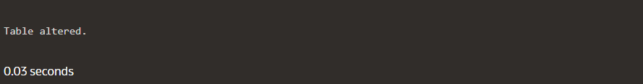

4. Create the EMPLOYEES2 table based on the structure of EMPLOYEES table. Include Only the Employee_id, First_name, Last_name, Salary and Dept_id coloumns. Name the columns Id, First_name, Last_name, salary and Dept_id respectively.

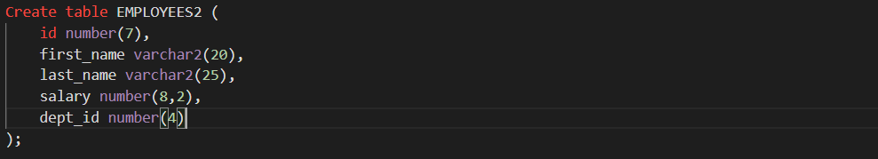

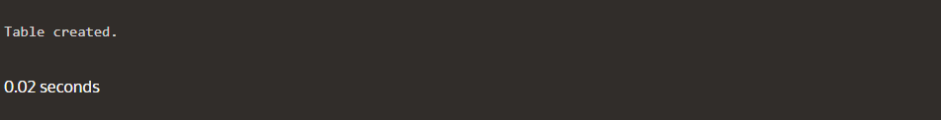

5. Drop the EMP table.



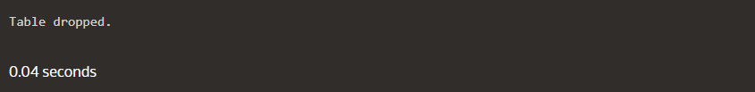

6. Rename the EMPLOYEES2 table as EMP.



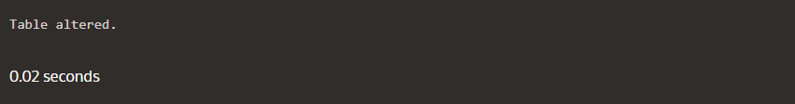

7. Add a comment on DEPT and EMP tables. Confirm the modification by describing the table.

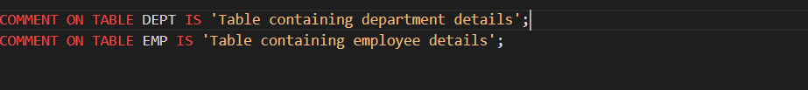

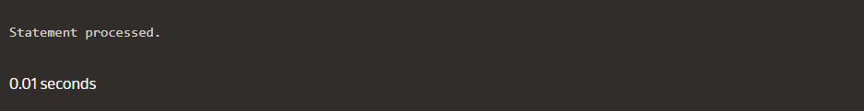

8. Drop the First_name column from the EMP table and confirm it.



